Name: Date:

GENERAL PHYSICS

Math Review

After reading Chapter One and Appendix A of the College Physics text on reserve in the Science Library, complete the following problems. These contain some of the math skills required to be successful in the Physics portion of this course and will make it easier for you to solve future problems.

Evaluate the following. Let x = 3

Solve for x in the following equations. Check your answer(s) below by substituting each solution into the original equation..

- 4x – 12 = 0

- 8x – 9 = 3x + 6

The general triangle shown below is on a standard rectangular coordinate system. Solve the following algebraic, geometric and trigonometric problems presented in #11 and #12.

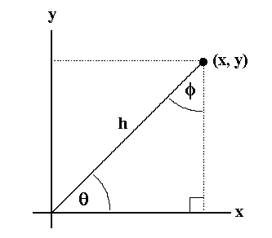
- If the length of h = 40.0 cm and θ = 60.0º , show your work, include units with your answers and determine the following:

φ =

x = y =

For the Triangle:
perimeter = area =

- If x = 16.0 cm and y = 12.0 cm, show your work, include units with your answers and determine the following:

sin θ = θ =

tan φ = φ =

For the Triangle:
perimeter = area =
- Complete the following table and on graph paper, graph the line for the equation

x – 2y = – 6

Identify the x-intercept and the y-intercept on your graph and indicate their values as ordered pairs below.

x | y
6
 | 4
8

x-intercept: y-intercept:

slope of the line, m =

slope-intercept form of the equation (y = mx + b) of the line is

Follow the instructions in the separate “An Introduction to Graphing in Excel” handout and use the three points to graph this line, place a trend line, and display the trend line equation on the graph to check the results you obtained above.

- Given the following points (6, 2), (9, 4) and (12, 6) graph the line on a rectangular coordinate system on graph paper. Identify the x-intercept and the y-intercept on your graph and indicate their values as ordered pairs below. Show your calculations below and determine the following:

x-intercept: y-intercept:

slope of the line, m =

standard form of the equation (ax + by = c) of this line is

slope-intercept form of the equation (y = mx + b) of the line is

Follow the instructions in the separate “An Introduction to Graphing in Excel” handout and use the three points to graph this line, place a trend line, and display the trend line equation on the graph to check the results you obtained above.

Write the following in scientific notation without using your calculator.
0.000122 cm = 80,600,000 km =
- Convert the following using the tables found inside the front cover and chapter one of the book on reserve (some of the same conversion information is also contained insede the front cover of your text) and your calculator. Show all of the steps of your conversions.

2.5 gallons = liters

28.6 inches = centimeters

4,980 centimeters = meters

4.0 miles / hour = feet / second

4.0 miles / hour = kilometers / hour

4.0 miles / hour = meters / second

