Design for a new Prime Focus Corrector on the
Wyoming InfraRed Observatory (WIRO)

Preliminary design of 6 May, 2003
PI: Chip Kobulnicky

Overview

This document describes the specifications for the fabrication of a new prime focus corrector for the 2.3 m f/2.1 Wyoming Infrared Observatory (WIRO) telescope on Mt. Jelm. This WIRO Prime Focus Corrector (WIROPFC) will consist of 4 fused quartz lenses in a common mount. It will greatly enhance the capabilities of the telescope by enabling imaging over wide fields of view with modern optical detectors and reinvigorate infrared capabilities by permitting wide-field imaging with infrared array detectors. The plate scale at the f/2.1 focus is 44”/mm or 0.044”/micron. Modern optical arrays such as the current WIRO Marconi 2k x 2k CCD have 13.5 micron pixels and focal planes which are 27.6 mm on a side, resulting in a 20.5' field of view. Modern infrared arrays such as the 2k x 2k Hawaii II HgCdTe arrays have 18 micron pixels and focal planes of 36.8 mm on a side, resulting in a 27.3' field of view. WIROPFC must correct the abberations from the parabolic primary (mostly coma) over at least this 27' field of view, and must have excellent transmissivity over a broad wavelength range from the blue wavelength limit of optical CCDs near 0.37 microns to the red wavelength limit of the HgCdTe infrared arrays (2.4 microns). WIROPFC must deliver an intrinsic point source spot size which is small compared to the typical seeing disk at the Mt Jelm site. For these purposes, we have set the design goals such that the mean field-averaged RMS spot size radius delivered by WIROPFC should ideally be less than 5 microns, i.e., less than half of 10 microns, which is the RMS radius of the typical 1” FWHM (σ=FWHM/2.35=0.42”) seeing at optical wavelengths.

Section I of this document describes the preliminary design and performance for WIROPFC.

Section II of this document includes detailed manufacturing specifications intended as a request for quote (RFQ) from optical fabricators. The manufacturing process is divided into four distinct “jobs” which may be bid upon individually or as a whole.

A. Quartz lens blank procurement
B. Lens fabrication & testing
C. Lens anti-reflection coating
D. Opto-mechanical mounting

I. WIROPFC Design

A. Optical material

The design for WIROPFC was performed in the ZEMAX software, stating with the current design of the 4-element Wynn corrector now in place. Fused quartz was chosen as the glass due its high transmissivity across the entire wavelength range of operation. Figure 1 below shows a typical transmissivity curve for fused quartz, including 3-4% reflectivity losses at each surface reflectivity losses. Actual transmission values will be provided by vendors.
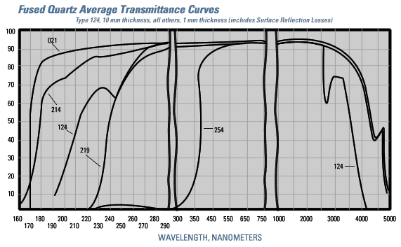
Figure 1: Transmissivity of Fused Quartz (from GE quartz web site)

B. Optical Configuration

For ease of manufacture and mounting, all lens elements were assumed to have spherical surfaces with a minimum center thickness of 4 mm and minimum edge thickness of 4 mm. The maximum allowed element thickness was 25 mm. These limits were based on experience with previous instrument designs, and may be relaxed if fabricators indicate that more extreme limits are within the scope of conventional production and mounting techniques.

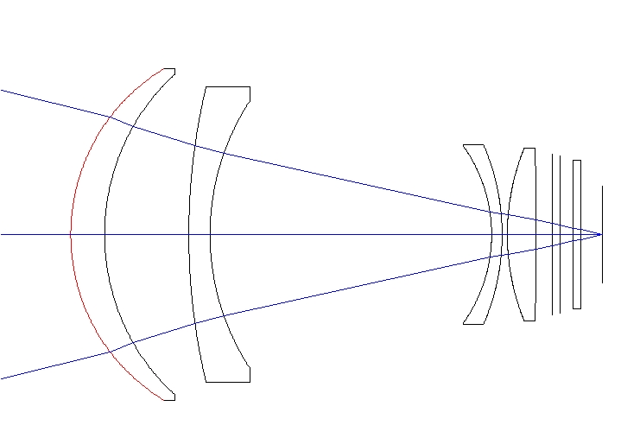
A ZEMAX optimization was performed to find an initial lens design that minimized the RMS spot size at wavelengths of 0.37 um, 0.55 um, 1.2 um, and 1.7 um, at four field angles of 0 degrees, 7' (i.e., 5' in X and Y), 14' (10' in XY), and 17' (12.3' in XY). The thickness, radius of curvature, and position of each surface, including the focal plane, was allowed to vary within the stated limits on glass thickness. A suitable configuration was found that produced an RMS spot size of 5-6 microns at all wavelengths averaged over the four field angles. Figure 2 below shows the 4-element design, with a filter and dewar window also shown.

Figure 2: Schematic of the 4-element WIROPFC with filter, dewar window and focal plane shown.

The full lens prescription is included in Appendix A. Specifications of the four fused quartz elements are shown in the table below. The mass of glass in all 4 elements is just under 0.7 kg. Final element specs will be determined by the designer after negotiation with the manufacturer, taking into consideration availability of test plates and cost/benefit analysis of tolerances. Lens A requires the most stringent tolerances and will be constructed first, allowing for errors to be taken up in the figuring of the final element, lens D.
SURFACE DATA SUMMARY (units in mm):
Surf Comment Radius Thickness Glass Diameter
2 LENSA 74.21655 12.91174 F_QUARTZ 126.8428
3 83.26644 32.16472 122.2856
4 LENSB 244.6905 8.10117 F_QUARTZ 112.9431
5 93.31473 107.49030 101.7049
6 LENSC -58.34811 4.00000 F_QUARTZ 67.2452
7 -86.37429 2.00000 68.5891
8 LENSD 87.62990 11.07370 F_QUARTZ 66.4473
9 -1057.2850 6.00000 65.0521

C. Optical Performance

The panels of Figure 3 below show the spot diagrams for the WIROPFC at 4 field angles at 4 wavelengths. A spot diagram at 0.55 microns for the current Wynn corrector is shown for comparison. The size of the scale box is 50 microns or 2.2”. The back focal distance is varied to minimize the spot size at each wavelength.

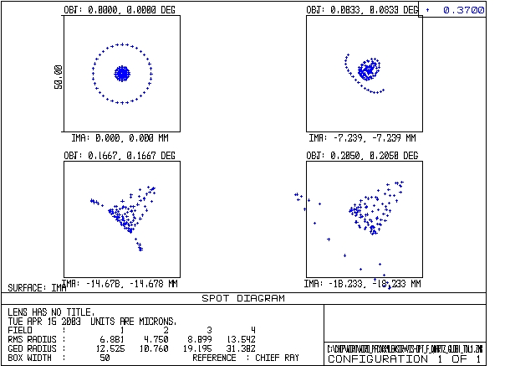
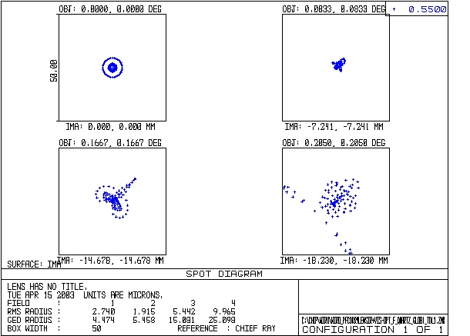
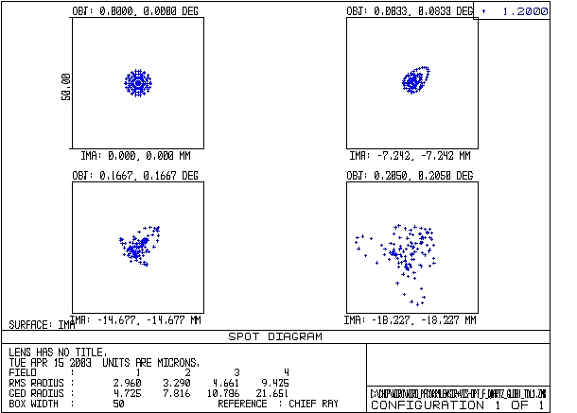
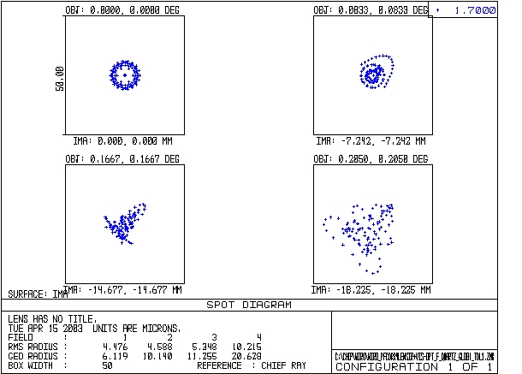
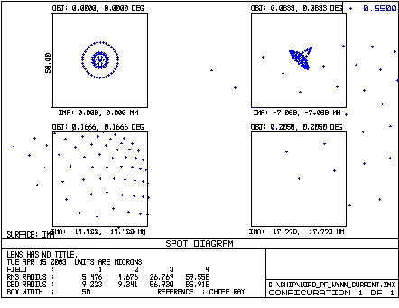
Figure 3: WIROPFC spot diagrams for 4 wavelengths. Four field angles are shown in each panel. The current Wynn corrector spot diagrams appears at lower center and illustrates the dramatic image quality improvement to be achieved at field angles larger than 7'.

Figure 4 illustrates the encircled energy as a function of radius for each of the 4 field angles at 0.55 microns with the new WIROPFC (left) versus the current Wynn Corrector (right).
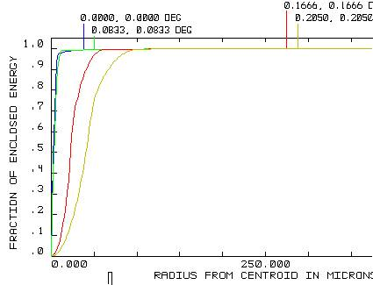
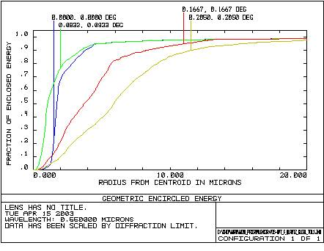
Figure 4: A comparison of the encircled energy at four different field angles for the WIROPFC (left) and the current Wynn corrector (right). Note different x-axis scales.

Figure 5 shows a spot diagram through focus indicating minimal field curvature.
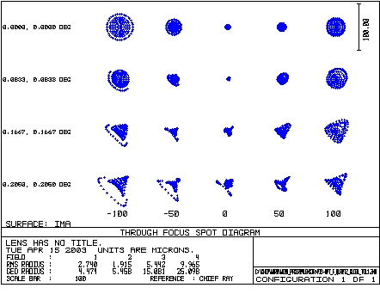
Figure 5: Spot diagram at 0.55 microns through focus as a function of field angle.

Figure 6 shows the degree of distortion (plate scale change) across the field. There is a significant amount of barrel distortion, with a maximum of 2.3% at the edge of the field.
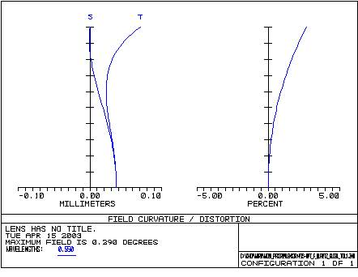
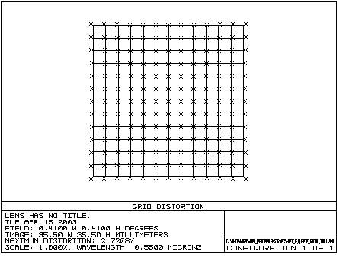
Figure 6: Distortion as a function of field distance at 0.55 microns.

Figure 7 shows the back focal distance variation as a function of wavelength. The focal shift can easily be accommodated by the range of motion of the CCD z stage.
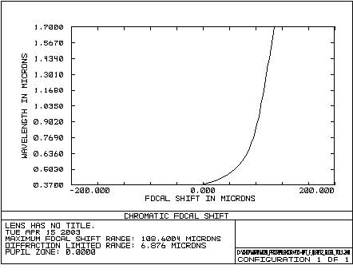
Figure 7: Chromatic focal shift

D. Tolerance Analysis

In order to understand the effects of lens manufacturing and mounting errors on optical performance, a ZEMAX tolerancing analysis was performed. This is done by performing a Monte-Carlo simulations which varies the radii of curvature, tilt, and centering, and thickness of each lens surface within a user-specified range. In general, the maximum allowed deviations from design specs were set as follows, based on an understanding of the precision achievable with careful conventional machining techniques.
 | Tolerance Type | Default Tolerance
TRAD | Tolerance on radius of curvature (mm) | 0.1% of radius
TETX/Y | Tolerance on element tilt in X and Y | 0.032 degrees
TEDX/Y | Tolerance on element decenter in X and Y | 0.075 mm
TSDX/Y | Tolerance on surface decenter in X and Y | 0.075 mm
TTHI | Tolerance on total thickness of a surface | 0.075 mm
TIND | Tolerance on index of refraction variations | 1.00E-005

Some elements require more exacting manufacture in order that the RMS spot size not exceed the 9 micron radius expected from the site seeing. Optical performance was found to be particularly sensitive to the radius of curvature on the the surfaces of Lens A. To achieve acceptable imaging performance requires that the radius of curvature on surface A1 be accurate to 0.02 mm (0.026%). The radius of curvature on surface A2 must be accurate to 0.042 mm (0.05%). These precisions may represent significant technical or cost barriers. In order to mitigate the restrictive tolerances on the radius of surfaces of lens A, we allowed the radius of surface D2 to vary as a compensating factor. If lens D is fabricated last, and its radius is adjusted to compensate for the final figure on lens A, then it is possible to relax the tolerances on surfaces A1 and A2 to 0.1%. Surface D2 was found to be a more potent compensator than any of the other surfaces. Surface B2 is also an acceptable compensator.

Additional constraints more exacting than nominal are:
The thickness of surface A1 (TTHI) must be accurate to 0.05 mm.
Surfaces A1 and C1 must be centered (TSDX/Y) to within 0.05 mm
Lens A and Lens C must be centered (TEDX/Y) to within 0.05 mm.

Appendix B shows the tolerance report for the 0.55 micron wavelength. The notable results of this analysis are that the expected RMS spot size based upon 30 Monte-Carlo simulations is 7.6 microns, i.e., 2.5 microns larger than the nominal error-free spot radius of 5.1 microns. This is still smaller than the RMS seeing size of 10 microns at optical wavelengths.
At infrared wavelengths where the site seeing is better than 1”, errors in the lens manufacture and mounting will likely produce spot sizes that exceed the seeing size. For 0.5” seeing, the native spot size is 4.8 microns. Because the WIROPFC does not perform as well in the infrared, the corrector-induced spot size will be considerably larger for the same manufacturing tolerances. However, this is mitigated by the fact that the pixels of a modern IR detector such as the Hawaii II array are larger (18 microns versus 13.5 microns), so that we will not be seeing limited in the infrared. Appendix C shows the tolerance report at 1.7 microns. The notable features of this report are that the mean RMS spot size indicated by 30 Monte-Carlo simulations is 8.6 microns, 2.1 microns larger than the nominal error-free spot size of 6.5 microns.

E. Thermal Sensitivity Analysis

WIROPFC must operate under a wide range of temperature conditions from 20 C, characteristic of manufacturing environments and warm summer evenings on Mt. Jelm, to -40 C, characteristic of cold winter nights, without performance degradation. Thermal expansion and contraction of the fused quartz and mounting material must not introduce abberations other than defocus, which can be corrected by varying the back focal distance. The coefficient of thermal expansion (CTE) of fused quartz is quite small at 0.51e-6. For simplicity, we assume that the lenses will be mounted on an aluminum optical bench. The CTE for aluminum is 23.5e-6. This means that the CTE of aluminum will dominate the thermal sensitivity of the design. Over a 60 deg variation in temperature, the distance between elements in WIROPFC (typically < 100 mm) will vary by 60 x 23.5E-6 x 100mm = 0.14 mm.

ZEMAX was used to perform a thermal analysis at temperatures of 20 C, 10 C, -15 C, and -40 C. In each case, the back focal distance is used compensate for defocus. At all temperatures, the RMS spot sizes are very similar to the nominal 5.9 microns radius after minimal refocus. The four spot diagrams in Figure 8 below show the variation in spot shape with temperature. Only at the most extreme -40 C does the spot size degrade significantly. Evan in this case, the RMS spot size is still less than 1 18 micron pixel, so we conclude that aluminum will be an acceptable material for the lens assembly.
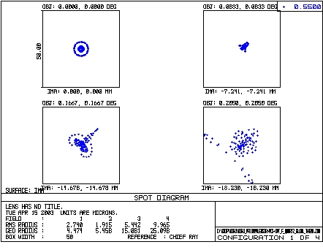
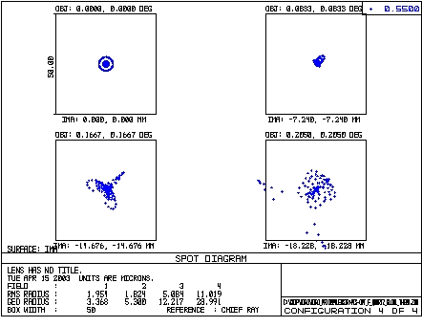
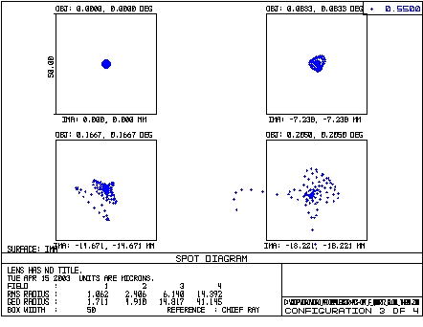
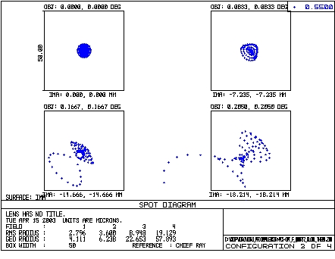
Figure 8: Variations in spot size at each field angle as a function of temperature at 20 C (upper left), 10 C (upper right), -15 C (lower left), and -40 C (lower right).

F. Anti-reflection Coating Options

At each air-glass interface, the typical reflective loss is 3-4%. If left uncoated, the 8 air-glass interfaces in WIROPFC would reduce the efficiency of the entire optical system to 0.72. With anti-reflection coatings, the losses can be reduced to between 0% and 2% for each surface. If the reflectivity could be reduced to 2% per surface, the efficiency of WIROPFC would be 0.85.

Most anti-reflection coatings are effective over a limited range of wavelengths. There are several commonly-used types of anti-reflection coatings for astronomical applications. Magnesium Fluoride (MgF2) has been a standard for many years because it is cheap and durable. The newest and most promising material is SolGel, which, when used in combination with conventional dielectric coatings, can reduce the reflectivity to near 0 over a limited wavelength range, and maintain reflectivities below 1% over an extended range. See Figure 9 for a comparison of SolGel to MgF2 coatings and uncoated surfaces (figure from the Cleveland Crystals website).
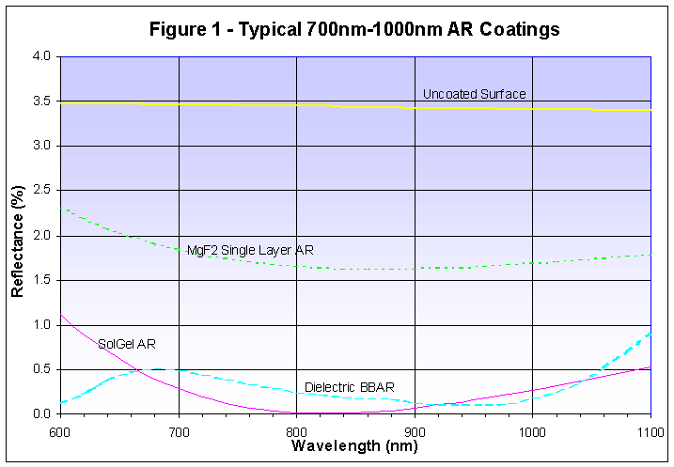
Figure 9: Comparison of the reflectivity of coated surfaces (courtesy of Cleveland Crystals web site)

The disadvantage of SolGel is that it is soft and easily damaged. Most instrument designers have elected to use SolGel on sealed interior surfaces only. Because of the dusty, exposed environment where WIROPFC will reside, we will consider SolGel for the 6 interior surfaces only. Conventional MgF2 coatings would be used on the exterior surfaces of lenses A and D. MgF2 coatings may be used on all surfaces if the SolGel is deemed too expensive or impractical because of handling and mounting concerns.

Potential coating vendors will be encouraged to submit reflectivity plots over the wavelength range 0.37 microns to 2.4 microns where WIROPFC is designed to be used.

- Manufacturing Specifications for the WIRO Prime Focus Corrector

Vendors shall be asked to bid on each of the four packages individually, and on the project as a whole.
Awards will be made on the basis of lowest net price for each job or the total project.

A. Fused Quartz Blanks

These optical blanks will be used to construct a Prime Focus corrector for the Wyoming InfraRed Observatory 2.3 m telescope.

Fused quartz optical blanks

Lens | Diameter(mm) | Thickness (mm)
A | 132 | 45
B | 120 | 28
C | 75 | 20
D | 74 | 16

Bubbles: cross section/100 cm^3 < 0.1
Bubble size < 0.28mm
Index uniformity: < 1.E-5
OH content: < 50 ppm
All properties at 20 C.
Desired delivery timescale: <4 weeks.

B. Lens Fabrication and analysis

The optical blanks will either be supplied by the customer or by the fabricator, TBD. The blanks will be oversized by 4-5 mm in thickness and 6 mm in diameter.

1. Fabricator will provide a finished optical elements meeting the physical specifications below. Fabricator will document the final surface figures on each surface.

- Fabricator will work with the customer to make maximal use of existing test places and implement changes that the fabricator might suggest to facilitate production and mitigate problems. One surface out of the 8 surfaces will be designated as a pickup surface and be fabricated last to compensate for the final figures on the initial 7 surfaces. All surfaces are spherical. All dimensions are in mm. Physical properties are stated at 20 C.
- Surface finish.
a. Shape: spherical Pitch polish to test place within ±0.5 fringe at 555 nm. Document and report final figure.
b. Radius tolerance: ±0.1% unless indicated. Document and report.
c. Surface finish: 1 nm RMS or better. Document and report measured values.
d. Diameter and thickness: ±0.075 mm unless otherwise indicated. Report to 0.01 mm.
e. Wedge: <20 microns edge thickness difference
f. Bevel edges 1mm at 45 deg: 1.4 mm max face width

C. Anti-reflection Coating

Vendor will provide a plot of transmissivity per surface over the wavelength range 0.37 microns to 2.4 microns. Vendor will document coating thickness and reflectivity across each element.

D. Opto-mechanical Mounting

Vendor will provide initial mechanical design and work with customer to arrive at final design. Vendor will fabricate assembly from aluminum or other specified material as agreed with customer, mount the elements, and document final tip/tilt, spacing, and centering achieved for each element.

E. Delivery timescale

Vendors wail indicate delivery timescale for each job.

APPENDIX A: Lens Prescription
-
System/Prescription Data

File : C:\Chip\WIRO\WIRO_PFcorr4lensIR+VIS-opt_F_quartz_glob1_tol1.ZMX
Title: Lens has no title.
Date : TUE APR 15 2003

LENS NOTES:

Notes...

GENERAL LENS DATA:

Surfaces : 14
Stop : 1
System Aperture : Entrance Pupil Diameter = 2300
Glass Catalogs : Schott OHARA INFRARED PFIS_0211
Ray Aiming : Off
Apodization :Uniform, factor = 0.00000E+000
Effective Focal Length : -4959.976 (in air at system temperature and pressure)
Effective Focal Length : -4959.976 (in image space)
Back Focal Length : -8.166326
Total Track : 4678.945
Image Space F/# : 2.156511
Paraxial Working F/# : 2.156511
Working F/# : 2.156281
Image Space NA : 0.2258645
Object Space NA : 1.15e-007
Stop Radius : 1150
Paraxial Image Height : 25.09744
Paraxial Magnification : 0
Entrance Pupil Diameter : 2300
Entrance Pupil Position : 0
Exit Pupil Diameter : 272.0045
Exit Pupil Position : 586.6181
Field Type : Angle in degrees
Maximum Field : 0.2899138
Primary Wave : 0.55
Lens Units : Millimeters
Angular Magnification : 8.455742

Fields : 4
Field Type: Angle in degrees
# X-Value Y-Value Weight
1 0.000000 0.000000 1.000000
2 0.083300 0.083300 1.000000
3 0.166670 0.166670 1.000000
4 0.205000 0.205000 1.000000

Vignetting Factors
# VDX VDY VCX VCY VAN
1 0.000000 0.000000 0.000000 0.000000 0.000000
2 0.000000 0.000000 0.000000 0.000000 0.000000
3 0.000000 0.000000 0.000000 0.000000 0.000000
4 0.000000 0.000000 0.000000 0.000000 0.000000

Wavelengths : 1
Units: Microns
# Value Weight
1 0.550000 1.000000

SURFACE DATA SUMMARY:

Surf Type Comment Radius Thickness Glass Diameter Conic
OBJ STANDARD Infinity Infinity 0
STO STANDARD PRIMARY 9340 4476 MIRROR 2300 -1
2 STANDARD LENS1 74.21655 12.91174 F_QUARTZ 126.8428 0
3 STANDARD 83.26644 32.16472 122.2856 0
4 STANDARD LENSE2 244.6905 8.101171 F_QUARTZ 112.9431 0
5 STANDARD 93.31473 107.4903 101.7049 0
6 STANDARD LENS3 -58.34811 3.999998 F_QUARTZ 67.24516 0
7 STANDARD -86.37429 1.999999 68.58905 0
8 STANDARD LENS4 87.6299 11.0737 F_QUARTZ 66.44733 0
9 STANDARD -1057.285 6 65.05213 0
10 STANDARD WINDOW Infinity 3 61.50002 0
11 STANDARD Infinity 5 59.86069 0
12 STANDARD FILTER Infinity 3 BK7 57.12848 0
13 STANDARD Infinity 8.203732 56.07104 0
IMA STANDARD Infinity 36.8 0

SURFACE DATA DETAIL:

Surface OBJ : STANDARD
Surface STO : STANDARD PRIMARY
Aperture : Floating Aperture
Maximum Radius : 1150
Surface 2 : STANDARD LENS1
Aperture : Floating Aperture
Maximum Radius : 63.42139
Surface 3 : STANDARD
Aperture : Floating Aperture
Maximum Radius : 61.14279
Surface 4 : STANDARD LENSE2
Aperture : Floating Aperture
Maximum Radius : 56.47156
Surface 5 : STANDARD
Aperture : Floating Aperture
Maximum Radius : 50.85246
Surface 6 : STANDARD LENS3
Aperture : Floating Aperture
Maximum Radius : 33.62258
Surface 7 : STANDARD
Aperture : Floating Aperture
Maximum Radius : 34.29452
Surface 8 : STANDARD LENS4
Aperture : Floating Aperture
Maximum Radius : 33.22367
Surface 9 : STANDARD
Aperture : Floating Aperture
Maximum Radius : 32.52607
Surface 10 : STANDARD WINDOW
Surface 11 : STANDARD
Surface 12 : STANDARD FILTER
Surface 13 : STANDARD
Surface IMA : STANDARD

COATING DEFINITIONS:

PHYSICAL OPTICS PROPAGATION SETTINGS SUMMARY:

OBJ STANDARD
Use Rays To Propagate To Next Surface : Off
Recompute Pilot Beam : Off
Do Not Rescale Beam Size Using Ray Data: Off
Use Angular Spectrum Propagator : Off
Reference Radius : Best Fit
STO STANDARD PRIMARY
Use Rays To Propagate To Next Surface : Off
Recompute Pilot Beam : Off
Do Not Rescale Beam Size Using Ray Data: Off
Use Angular Spectrum Propagator : Off
Reference Radius : Best Fit
2 STANDARD LENS1
Use Rays To Propagate To Next Surface : Off
Recompute Pilot Beam : Off
Do Not Rescale Beam Size Using Ray Data: Off
Use Angular Spectrum Propagator : Off
Reference Radius : Best Fit
3 STANDARD
Use Rays To Propagate To Next Surface : Off
Recompute Pilot Beam : Off
Do Not Rescale Beam Size Using Ray Data: Off
Use Angular Spectrum Propagator : Off
Reference Radius : Best Fit
4 STANDARD LENSE2
Use Rays To Propagate To Next Surface : Off
Recompute Pilot Beam : Off
Do Not Rescale Beam Size Using Ray Data: Off
Use Angular Spectrum Propagator : Off
Reference Radius : Best Fit
5 STANDARD
Use Rays To Propagate To Next Surface : Off
Recompute Pilot Beam : Off
Do Not Rescale Beam Size Using Ray Data: Off
Use Angular Spectrum Propagator : Off
Reference Radius : Best Fit
6 STANDARD LENS3
Use Rays To Propagate To Next Surface : Off
Recompute Pilot Beam : Off
Do Not Rescale Beam Size Using Ray Data: Off
Use Angular Spectrum Propagator : Off
Reference Radius : Best Fit
7 STANDARD
Use Rays To Propagate To Next Surface : Off
Recompute Pilot Beam : Off
Do Not Rescale Beam Size Using Ray Data: Off
Use Angular Spectrum Propagator : Off
Reference Radius : Best Fit
8 STANDARD LENS4
Use Rays To Propagate To Next Surface : Off
Recompute Pilot Beam : Off
Do Not Rescale Beam Size Using Ray Data: Off
Use Angular Spectrum Propagator : Off
Reference Radius : Best Fit
9 STANDARD
Use Rays To Propagate To Next Surface : Off
Recompute Pilot Beam : Off
Do Not Rescale Beam Size Using Ray Data: Off
Use Angular Spectrum Propagator : Off
Reference Radius : Best Fit
10 STANDARD WINDOW
Use Rays To Propagate To Next Surface : Off
Recompute Pilot Beam : Off
Do Not Rescale Beam Size Using Ray Data: Off
Use Angular Spectrum Propagator : Off
Reference Radius : Best Fit
11 STANDARD
Use Rays To Propagate To Next Surface : Off
Recompute Pilot Beam : Off
Do Not Rescale Beam Size Using Ray Data: Off
Use Angular Spectrum Propagator : Off
Reference Radius : Best Fit
12 STANDARD FILTER
Use Rays To Propagate To Next Surface : Off
Recompute Pilot Beam : Off
Do Not Rescale Beam Size Using Ray Data: Off
Use Angular Spectrum Propagator : Off
Reference Radius : Best Fit
13 STANDARD
Use Rays To Propagate To Next Surface : Off
Recompute Pilot Beam : Off
Do Not Rescale Beam Size Using Ray Data: Off
Use Angular Spectrum Propagator : Off
Reference Radius : Best Fit
IMA STANDARD
Use Rays To Propagate To Next Surface : Off
Recompute Pilot Beam : Off
Do Not Rescale Beam Size Using Ray Data: Off
Use Angular Spectrum Propagator : Off
Reference Radius : Best Fit

EDGE THICKNESS DATA:

Surf X-Edge Y-Edge
STO 4440.872523 4440.872523
2 3.984925 3.984925
3 12.026997 12.026997
4 16.569193 16.569193
5 81.755224 81.755224
6 7.561319 7.561319
7 15.642428 15.642428
8 4.030902 4.030902
9 6.500431 6.500431
10 3.000000 3.000000
11 5.000000 5.000000
12 3.000000 3.000000
13 8.203732 8.203732
IMA 0.000000 0.000000

SOLVE AND VARIABLE DATA:

Semi Diameter 1 : Fixed
Thickness of 13 : Variable
Semi Diameter 14 : Fixed

INDEX OF REFRACTION DATA:

Surf Glass Temp Pres 0.550000
0 20.00 1.00 1.00000000
1 MIRROR 20.00 1.00 1.00000000
2 F_QUARTZ 20.00 1.00 1.46001255
3 20.00 1.00 1.00000000
4 F_QUARTZ 20.00 1.00 1.46001255
5 20.00 1.00 1.00000000
6 F_QUARTZ 20.00 1.00 1.46001255
7 20.00 1.00 1.00000000
8 F_QUARTZ 20.00 1.00 1.46001255
9 20.00 1.00 1.00000000
10 20.00 1.00 1.00000000
11 20.00 1.00 1.00000000
12 BK7 20.00 1.00 1.51852239
13 20.00 1.00 1.00000000
14 20.00 1.00 1.00000000

THERMAL COEFFICIENT OF EXPANSION DATA:

Surf Glass TCE *10E-6
0 0.00000000
1 MIRROR 0.00000000
2 F_QUARTZ 0.51000000
3 0.00000000
4 F_QUARTZ 0.51000000
5 0.00000000
6 F_QUARTZ 0.51000000
7 0.00000000
8 F_QUARTZ 0.51000000
9 0.00000000
10 0.00000000
11 0.00000000
12 BK7 7.10000000
13 0.00000000
14 0.00000000

F/# DATA:

F/# calculations consider vignetting factors and ignore surface apertures.

Wavelength: 0.550000
# Field Tan Sag
1 0.0000, 0.0000 deg: 2.1563 2.1563
2 0.0833, 0.0833 deg: 2.1739 2.1739
3 0.1667, 0.1667 deg: 2.2320 2.2320
4 0.2050, 0.2050 deg: 2.2771 2.2771

GLOBAL VERTEX COORDINATES, ORIENTATIONS, AND ROTATION/OFFSET MATRICES:

Reference Surface: 1

Surf R11 R12 R13 X
R21 R22 R23 Y
R31 R32 R33 Z

1 1.0000000000 0.0000000000 0.0000000000 0.000000000E+000 PRIMARY
0.0000000000 1.0000000000 0.0000000000 0.000000000E+000
0.0000000000 0.0000000000 1.0000000000 0.000000000E+000

2 1.0000000000 0.0000000000 0.0000000000 0.000000000E+000 LENS1
0.0000000000 1.0000000000 0.0000000000 0.000000000E+000
0.0000000000 0.0000000000 1.0000000000 4.476000000E+003

3 1.0000000000 0.0000000000 0.0000000000 0.000000000E+000
0.0000000000 1.0000000000 0.0000000000 0.000000000E+000
0.0000000000 0.0000000000 1.0000000000 4.488911742E+003

4 1.0000000000 0.0000000000 0.0000000000 0.000000000E+000 LENSE2
0.0000000000 1.0000000000 0.0000000000 0.000000000E+000
0.0000000000 0.0000000000 1.0000000000 4.521076458E+003

5 1.0000000000 0.0000000000 0.0000000000 0.000000000E+000
0.0000000000 1.0000000000 0.0000000000 0.000000000E+000
0.0000000000 0.0000000000 1.0000000000 4.529177629E+003

6 1.0000000000 0.0000000000 0.0000000000 0.000000000E+000 LENS3
0.0000000000 1.0000000000 0.0000000000 0.000000000E+000
0.0000000000 0.0000000000 1.0000000000 4.636667888E+003

7 1.0000000000 0.0000000000 0.0000000000 0.000000000E+000
0.0000000000 1.0000000000 0.0000000000 0.000000000E+000
0.0000000000 0.0000000000 1.0000000000 4.640667886E+003

8 1.0000000000 0.0000000000 0.0000000000 0.000000000E+000 LENS4
0.0000000000 1.0000000000 0.0000000000 0.000000000E+000
0.0000000000 0.0000000000 1.0000000000 4.642667885E+003

9 1.0000000000 0.0000000000 0.0000000000 0.000000000E+000
0.0000000000 1.0000000000 0.0000000000 0.000000000E+000
0.0000000000 0.0000000000 1.0000000000 4.653741588E+003

10 1.0000000000 0.0000000000 0.0000000000 0.000000000E+000 WINDOW
0.0000000000 1.0000000000 0.0000000000 0.000000000E+000
0.0000000000 0.0000000000 1.0000000000 4.659741588E+003

11 1.0000000000 0.0000000000 0.0000000000 0.000000000E+000
0.0000000000 1.0000000000 0.0000000000 0.000000000E+000
0.0000000000 0.0000000000 1.0000000000 4.662741588E+003

12 1.0000000000 0.0000000000 0.0000000000 0.000000000E+000 FILTER
0.0000000000 1.0000000000 0.0000000000 0.000000000E+000
0.0000000000 0.0000000000 1.0000000000 4.667741588E+003

13 1.0000000000 0.0000000000 0.0000000000 0.000000000E+000
0.0000000000 1.0000000000 0.0000000000 0.000000000E+000
0.0000000000 0.0000000000 1.0000000000 4.670741588E+003

14 1.0000000000 0.0000000000 0.0000000000 0.000000000E+000
0.0000000000 1.0000000000 0.0000000000 0.000000000E+000
0.0000000000 0.0000000000 1.0000000000 4.678945320E+003

ELEMENT VOLUME DATA:

Values are only accurate for plane and spherical surfaces.
Element volumes are computed by assuming edges are squared up
to the larger of the front and back radial aperture.
Single elements that are duplicated in the Lens Data Editor
for ray tracing purposes may be listed more than once yielding
incorrect total mass estimates.

Volume cc Density g/cc Mass g
Element surf 2 to 3 132.428177 2.200000 291.341989
Element surf 4 to 5 136.218683 2.200000 299.681102
Element surf 6 to 7 21.675959 2.200000 47.687110
Element surf 8 to 9 26.299963 2.200000 57.859918
Element surf 12 to 13 7.689825 2.510000 19.301460
Total Mass: 715.871578

CARDINAL POINTS:

Object space positions are measured with respect to surface 1.
Image space positions are measured with respect to the image surface.
The index in both the object space and image space is considered.

Object Space Image Space
W = 0.550000 (Primary)
Focal Length : 4959.975555 4959.975555
Focal Planes : 41940.275046 0.037406
Principal Planes : 36980.299491 -4959.938150
Anti-Principal Planes : 46900.250601 4960.012961
Nodal Planes : 46900.250601 4960.012961
Anti-Nodal Planes : 36980.299491 -4959.938150

APPENDIX B: Tolerance Analysis at 0.55 microns

Analysis of Tolerances
File : C:\Chip\WIRO\WIRO_PFcorr4lensIR+VIS-opt_F_quartz_glob1_tol1.ZMX
Title: Lens has no title.
Date : TUE APR 15 2003
Units are Millimeters.
Fast tolerancing mode is on. In this mode, all
compensators are ignored, except back focus error.
WARNING: RAY AIMING IS OFF. Very loose tolerances may not be computed accurately.
WARNING: Boundary constraints on compensators are ignored when
using fast mode or user-defined merit functions.

Mode : Sensitivities
Sampling : 20
Optimization Cycles : Automatic mode

Merit: RMS Spot Radius in Millimeters

Nominal Merit Function (MF) is 0.00518177

Test wavelength: 0.5500

Fields: XY Symmetric Angle in degrees
# X-Field Y-Field Weight VDX VDY VCX VCY
1 0.000E+000 0.000E+000 4.000E+000 0.000 0.000 0.000 0.000
2 0.000E+000 2.029E-001 1.000E+000 0.000 0.000 0.000 0.000
3 0.000E+000 -2.029E-001 1.000E+000 0.000 0.000 0.000 0.000
4 0.000E+000 2.899E-001 1.000E+000 0.000 0.000 0.000 0.000
5 0.000E+000 -2.899E-001 1.000E+000 0.000 0.000 0.000 0.000
6 2.029E-001 0.000E+000 1.000E+000 0.000 0.000 0.000 0.000
7 -2.029E-001 0.000E+000 1.000E+000 0.000 0.000 0.000 0.000
8 2.899E-001 0.000E+000 1.000E+000 0.000 0.000 0.000 0.000
9 -2.899E-001 0.000E+000 1.000E+000 0.000 0.000 0.000 0.000

Sensitivity Analysis:
Detailed printing off.
Worst offenders:
Type Value MF Change
TRAD 2 0.020000 0.006546 0.001364
TSDX 6 -0.050000 0.006509 0.001327
TSDY 6 -0.050000 0.006509 0.001327
TSDY 6 0.050000 0.006509 0.001327
TSDX 6 0.050000 0.006509 0.001327
TRAD 6 0.060700 0.006302 0.001120
TTHI 2 3 -0.050000 0.006109 0.000927
TSDX 2 0.050000 0.006094 0.000913
TSDY 2 0.050000 0.006094 0.000913
TSDY 2 -0.050000 0.006094 0.000913
TSDX 2 -0.050000 0.006094 0.000913
TRAD 3 -0.042000 0.005991 0.000810
TEDX 2 3 -0.050000 0.005913 0.000731
TEDX 2 3 0.050000 0.005913 0.000731
TEDY 2 3 -0.050000 0.005913 0.000731
TEDY 2 3 0.050000 0.005913 0.000731
TRAD 5 -0.089600 0.005865 0.000683
TEDX 6 7 -0.050000 0.005840 0.000658
TEDY 6 7 -0.050000 0.005840 0.000658
TEDY 6 7 0.050000 0.005840 0.000658
TEDX 6 7 0.050000 0.005840 0.000658
TTHI 5 7 -0.075000 0.005771 0.000589
TTHI 3 5 -0.075000 0.005770 0.000588
TTHI 4 5 -0.075000 0.005765 0.000584
TETY 2 3 0.032000 0.005699 0.000517
TETX 2 3 -0.032000 0.005699 0.000517
TETX 2 3 0.032000 0.005699 0.000517
TETY 2 3 -0.032000 0.005699 0.000517
TRAD 2 -0.020000 0.005685 0.000503
TSDY 3 -0.075000 0.005570 0.000389
TSDX 3 0.075000 0.005570 0.000389
TSDY 3 0.075000 0.005570 0.000389
TSDX 3 -0.075000 0.005570 0.000389
TTHI 2 3 0.050000 0.005541 0.000359
TSDX 7 0.075000 0.005517 0.000335
TSDY 7 0.075000 0.005517 0.000335
TSDY 7 -0.075000 0.005517 0.000335
TSDX 7 -0.075000 0.005517 0.000335
TRAD 4 0.225600 0.005503 0.000322
TRAD 6 -0.060700 0.005483 0.000302
TRAD 3 0.042000 0.005468 0.000286
TRAD 7 -0.096200 0.005441 0.000260
TIRR 1 -0.200000 0.005415 0.000233
TETY 6 7 0.032000 0.005374 0.000192
TETX 6 7 -0.032000 0.005374 0.000192
TETX 6 7 0.032000 0.005374 0.000192
TETY 6 7 -0.032000 0.005374 0.000192
TIRX 6 0.020000 0.005359 0.000177
TIRY 6 -0.020000 0.005359 0.000177
TIRY 6 0.020000 0.005359 0.000177

Nominal RMS Spot Radius : 0.005182
Estimated change : 0.003448
Estimated RMS Spot Radius: 0.008630

Merit Statistics:
Mean : 0.005330
Standard Deviation : 0.000297

Compensator Statistics:
Change in back focus:
Minimum : -0.100857
Maximum : 0.100959
Mean : 0.000002
Standard Deviation : 0.020317

Monte Carlo Analysis:
Number of trials: 30

Initial Statistics: Normal Distribution
0.0, 0.0 0.0, 0.7 0.0, -0.7 0.0, 1.0 0.0, -1.0 0.7, 0.0 -0.7, 0.0 1.0, 0.0 -1.0, 0.0
Trial Merit Change Field 1 Field 2 Field 3 Field 4 Field 5 Field 6 Field 7 Field 8 Field 9
1 0.006308 0.001126 0.003111 0.002610 0.007260 0.008663 0.010844 0.004035 0.005637 0.007963 0.008666
2 0.007213 0.002031 0.004505 0.007770 0.005142 0.011695 0.008256 0.004847 0.007406 0.008181 0.010299
3 0.005602 0.000420 0.003225 0.002851 0.006075 0.007752 0.008638 0.003877 0.004961 0.007395 0.007805
4 0.007486 0.002304 0.004782 0.007303 0.004795 0.010664 0.010647 0.003406 0.007623 0.010003 0.010381
5 0.006800 0.001618 0.002902 0.004184 0.005526 0.007815 0.008539 0.008940 0.003075 0.012120 0.010140
6 0.006363 0.001181 0.002633 0.003769 0.005847 0.011132 0.008210 0.003044 0.005827 0.010707 0.007782
7 0.008425 0.003243 0.004123 0.003780 0.010606 0.010604 0.015253 0.003683 0.008568 0.008727 0.012196
8 0.008360 0.003178 0.004632 0.005671 0.004918 0.012089 0.009229 0.007602 0.006605 0.009696 0.016424
9 0.006189 0.001007 0.003584 0.003266 0.003349 0.010404 0.008313 0.002997 0.003835 0.011194 0.007751
10 0.007443 0.002261 0.003999 0.005472 0.005444 0.008005 0.013908 0.004142 0.004866 0.013453 0.007866
11 0.006211 0.001030 0.003645 0.003620 0.003707 0.010242 0.007767 0.004362 0.003847 0.007501 0.011300
12 0.009436 0.004254 0.004079 0.004175 0.004450 0.012431 0.011779 0.008659 0.006635 0.021751 0.008899
13 0.010856 0.005674 0.004504 0.003803 0.008462 0.011010 0.022530 0.006301 0.004847 0.017644 0.015612
14 0.007866 0.002684 0.004277 0.003773 0.005341 0.007804 0.015906 0.004459 0.003364 0.014425 0.008565
15 0.008509 0.003327 0.004577 0.008004 0.006098 0.010988 0.015351 0.004657 0.006848 0.013019 0.009447
16 0.007077 0.001895 0.003531 0.006540 0.003629 0.009723 0.007802 0.003726 0.008746 0.009829 0.012361
17 0.006218 0.001037 0.004145 0.003992 0.004526 0.011351 0.007801 0.003051 0.003655 0.008226 0.008879
18 0.010848 0.005667 0.004082 0.013700 0.008322 0.019045 0.019253 0.005100 0.008273 0.011286 0.011551
19 0.008589 0.003408 0.004542 0.005655 0.005304 0.013873 0.009241 0.006607 0.006505 0.017324 0.008874
20 0.006056 0.000874 0.003979 0.005932 0.004040 0.008805 0.009650 0.003561 0.004479 0.007919 0.007689
21 0.007496 0.002314 0.004117 0.003780 0.003524 0.011597 0.011620 0.003958 0.003761 0.013123 0.010399
22 0.007496 0.002315 0.003532 0.008376 0.004020 0.011695 0.007538 0.008947 0.004527 0.013407 0.008013
23 0.007093 0.001912 0.004180 0.003844 0.003900 0.012143 0.008824 0.004220 0.004224 0.013342 0.008059
24 0.006871 0.001690 0.003698 0.004761 0.003552 0.007553 0.009544 0.006878 0.004924 0.009371 0.013005
25 0.006915 0.001733 0.004179 0.006086 0.004504 0.008510 0.013267 0.003836 0.004366 0.008801 0.009325
26 0.009438 0.004256 0.003886 0.006323 0.011793 0.016147 0.017529 0.006523 0.004533 0.010216 0.009692
27 0.007931 0.002749 0.003541 0.010099 0.002971 0.014817 0.010453 0.007365 0.004829 0.010327 0.008991
28 0.010539 0.005357 0.003444 0.004052 0.004916 0.010266 0.014422 0.008695 0.010838 0.010408 0.025099
29 0.007522 0.002340 0.004293 0.003215 0.003450 0.010797 0.009128 0.004976 0.005861 0.008017 0.016114
30 0.006934 0.001753 0.004258 0.007356 0.003900 0.009966 0.009623 0.003581 0.007224 0.009255 0.009623

Nominal 0.005182 0.003459 0.003175 0.003175 0.007649 0.007649 0.003175 0.003175 0.007649 0.007649
Best 0.005602 0.002633 0.002610 0.002971 0.007553 0.007538 0.002997 0.003075 0.007395 0.007689
Worst 0.010856 0.004782 0.013700 0.011793 0.019045 0.022530 0.008947 0.010838 0.021751 0.025099
Mean 0.007670 0.003933 0.005459 0.005312 0.010920 0.011362 0.005201 0.005690 0.011154 0.010694
Std Dev 0.001389 0.000523 0.002395 0.002072 0.002534 0.003764 0.001896 0.001843 0.003305 0.003604

Compensator Statistics:
Change in back focus:
Minimum : -0.114244
Maximum : 0.144870
Mean : 0.007411
Standard Deviation : 0.076874

90% of Monte Carlo lenses have a merit function below 0.009438.
50% of Monte Carlo lenses have a merit function below 0.007443.
10% of Monte Carlo lenses have a merit function below 0.006189.

End of Run.
APPENDIX C: Tolerance Analysis at 1.7 microns

Analysis of Tolerances
File : C:\Chip\WIRO\WIRO_PFcorr4lensIR+VIS-opt_F_quartz_glob1_tol1.ZMX
Title: Lens has no title.
Date : TUE APR 15 2003
Units are Millimeters.
Fast tolerancing mode is on. In this mode, all
compensators are ignored, except back focus error.
WARNING: RAY AIMING IS OFF. Very loose tolerances may not be computed accurately.
WARNING: Boundary constraints on compensators are ignored when
using fast mode or user-defined merit functions.
Mode : Sensitivities
Sampling : 20
Optimization Cycles : Automatic mode

Merit: RMS Spot Radius in Millimeters

Nominal Merit Function (MF) is 0.00659792

Test wavelength: 1.7000

Fields: XY Symmetric Angle in degrees
# X-Field Y-Field Weight VDX VDY VCX VCY
1 0.000E+000 0.000E+000 4.000E+000 0.000 0.000 0.000 0.000
2 0.000E+000 2.029E-001 1.000E+000 0.000 0.000 0.000 0.000
3 0.000E+000 -2.029E-001 1.000E+000 0.000 0.000 0.000 0.000
4 0.000E+000 2.899E-001 1.000E+000 0.000 0.000 0.000 0.000
5 0.000E+000 -2.899E-001 1.000E+000 0.000 0.000 0.000 0.000
6 2.029E-001 0.000E+000 1.000E+000 0.000 0.000 0.000 0.000
7 -2.029E-001 0.000E+000 1.000E+000 0.000 0.000 0.000 0.000
8 2.899E-001 0.000E+000 1.000E+000 0.000 0.000 0.000 0.000
9 -2.899E-001 0.000E+000 1.000E+000 0.000 0.000 0.000 0.000

Sensitivity Analysis:
Detailed printing off.
Worst offenders:
Type Value MF Change
TRAD 2 0.020000 0.007791 0.001193
TSDX 6 -0.050000 0.007655 0.001057
TSDY 6 0.050000 0.007655 0.001057
TSDY 6 -0.050000 0.007655 0.001057
TSDX 6 0.050000 0.007655 0.001057
TRAD 6 0.060700 0.007585 0.000987
TTHI 2 3 -0.050000 0.007579 0.000981
TRAD 3 -0.042000 0.007492 0.000894
TSDY 2 0.050000 0.007323 0.000725
TSDX 2 0.050000 0.007323 0.000725
TSDX 2 -0.050000 0.007323 0.000725
TSDY 2 -0.050000 0.007323 0.000725
TRAD 5 -0.089600 0.007210 0.000612
TEDX 2 3 0.050000 0.007171 0.000573
TEDY 2 3 -0.050000 0.007171 0.000573
TEDY 2 3 0.050000 0.007171 0.000573
TEDX 2 3 -0.050000 0.007171 0.000573
TTHI 3 5 -0.075000 0.007157 0.000559
TTHI 4 5 -0.075000 0.007131 0.000534
TEDX 6 7 -0.050000 0.007113 0.000515
TEDY 6 7 0.050000 0.007113 0.000515
TEDY 6 7 -0.050000 0.007113 0.000515
TEDX 6 7 0.050000 0.007113 0.000515
TIRR 1 0.200000 0.007112 0.000514
TTHI 5 7 -0.075000 0.007042 0.000444
TETX 2 3 0.032000 0.006996 0.000398
TETX 2 3 -0.032000 0.006996 0.000398
TETY 2 3 0.032000 0.006996 0.000398
TETY 2 3 -0.032000 0.006996 0.000398
TSDY 3 -0.075000 0.006874 0.000276
TSDX 3 0.075000 0.006874 0.000276
TSDX 3 -0.075000 0.006874 0.000276
TSDY 3 0.075000 0.006874 0.000276
TSDX 7 0.075000 0.006856 0.000258
TSDY 7 -0.075000 0.006856 0.000258
TSDY 7 0.075000 0.006856 0.000258
TSDX 7 -0.075000 0.006856 0.000258
TRAD 2 -0.020000 0.006838 0.000240
TRAD 7 -0.096200 0.006820 0.000223
TRAD 4 0.225600 0.006782 0.000184
TETY 6 7 0.032000 0.006746 0.000149
TETX 6 7 0.032000 0.006746 0.000149
TETX 6 7 -0.032000 0.006746 0.000149
TETY 6 7 -0.032000 0.006746 0.000149
TIRX 6 0.020000 0.006734 0.000136
TIRY 6 0.020000 0.006734 0.000136
TIRY 6 -0.020000 0.006734 0.000136
TIRX 6 -0.020000 0.006734 0.000136
TRAD 6 -0.060700 0.006720 0.000122
TETY 4 5 0.032000 0.006705 0.000107

Nominal RMS Spot Radius : 0.006598
Estimated change : 0.002847
Estimated RMS Spot Radius: 0.009445

Merit Statistics:
Mean : 0.006714
Standard Deviation : 0.000248

Compensator Statistics:
Change in back focus:
Minimum : -0.096702
Maximum : 0.096799
Mean : 0.000002
Standard Deviation : 0.019622

Monte Carlo Analysis:
Number of trials: 30

Initial Statistics: Normal Distribution

0.0, 0.0 0.0, 0.7 0.0, -0.7 0.0, 1.0 0.0, -1.0 0.7, 0.0 -0.7, 0.0 1.0, 0.0 -1.0, 0.0
Trial Merit Change Field 1 Field 2 Field 3 Field 4 Field 5 Field 6 Field 7 Field 8 Field 9
1 0.012433 0.005835 0.005865 0.006274 0.008768 0.014626 0.020341 0.011005 0.006740 0.026858 0.009251
2 0.008539 0.001941 0.005020 0.006689 0.006766 0.012269 0.010393 0.006872 0.007567 0.015664 0.008675
3 0.006803 0.000205 0.004351 0.005545 0.004770 0.008935 0.010051 0.005510 0.004613 0.008588 0.010953
4 0.008460 0.001862 0.004432 0.010015 0.006950 0.012033 0.008351 0.011265 0.006205 0.013397 0.008496
5 0.007910 0.001312 0.004252 0.011021 0.005646 0.012738 0.008520 0.007946 0.008136 0.009177 0.008761
6 0.007962 0.001364 0.004325 0.005578 0.006798 0.012006 0.008773 0.008562 0.005511 0.008929 0.014283
7 0.008180 0.001582 0.004377 0.008319 0.005697 0.009247 0.015933 0.005164 0.006362 0.011228 0.009598
8 0.009882 0.003284 0.005060 0.009884 0.007401 0.011253 0.018732 0.006712 0.008062 0.015736 0.009044
9 0.008284 0.001686 0.004649 0.006976 0.005780 0.008808 0.015919 0.006098 0.005360 0.008757 0.013468
10 0.011339 0.004741 0.005539 0.010635 0.008441 0.012507 0.020333 0.008149 0.009776 0.019620 0.010913
11 0.011293 0.004695 0.004419 0.006265 0.008044 0.017348 0.011553 0.010431 0.008870 0.010563 0.024796
12 0.008413 0.001815 0.004276 0.005276 0.005365 0.012393 0.011552 0.007055 0.005487 0.009760 0.016046
13 0.008319 0.001721 0.004201 0.005645 0.004933 0.010093 0.014948 0.005614 0.005205 0.010097 0.014759
14 0.012070 0.005472 0.004957 0.007332 0.006582 0.017831 0.014738 0.010454 0.008583 0.027527 0.008768
15 0.008595 0.001998 0.004180 0.005870 0.008260 0.016487 0.008977 0.005374 0.007225 0.014278 0.008755
16 0.007028 0.000430 0.004719 0.006929 0.006478 0.008870 0.008930 0.007469 0.006027 0.008242 0.009758
17 0.009984 0.003386 0.004766 0.009908 0.008903 0.011233 0.010312 0.005629 0.014566 0.011184 0.018064
18 0.007102 0.000504 0.004470 0.007032 0.005157 0.008556 0.009655 0.007891 0.004848 0.009019 0.010756
19 0.008749 0.002151 0.004278 0.005084 0.011942 0.009826 0.014545 0.010353 0.005936 0.012246 0.008737
20 0.009021 0.002423 0.004160 0.007408 0.006649 0.008882 0.008707 0.013198 0.005600 0.015583 0.014325
21 0.010434 0.003836 0.004516 0.011714 0.010718 0.013596 0.013553 0.010623 0.011515 0.012818 0.013946
22 0.007928 0.001330 0.004844 0.007001 0.006464 0.009743 0.009641 0.009223 0.005441 0.009720 0.013135
23 0.008088 0.001490 0.004642 0.005019 0.010657 0.011836 0.012643 0.007798 0.005490 0.009497 0.008879
24 0.011993 0.005395 0.004114 0.006147 0.005937 0.017814 0.017236 0.009311 0.007098 0.026996 0.010248
25 0.008020 0.001422 0.004889 0.009903 0.006594 0.011166 0.008801 0.009106 0.007435 0.010628 0.009024
26 0.007968 0.001370 0.004539 0.010604 0.005580 0.011238 0.011535 0.007437 0.007522 0.008831 0.009310
27 0.007427 0.000829 0.004327 0.009797 0.005472 0.010514 0.009667 0.007358 0.007423 0.008792 0.008401
28 0.010528 0.003930 0.004847 0.008624 0.008594 0.022211 0.008761 0.006578 0.007458 0.017314 0.010913
29 0.007305 0.000707 0.004311 0.007274 0.005219 0.009188 0.010580 0.005244 0.007287 0.011714 0.008469
30 0.007316 0.000718 0.004408 0.006009 0.009075 0.009193 0.009468 0.008581 0.006391 0.009131 0.008602

Nominal 0.006598 0.004160 0.005754 0.005754 0.008955 0.008955 0.005754 0.005754 0.008955 0.008955
Best 0.006803 0.004114 0.005019 0.004770 0.008556 0.008351 0.005164 0.004613 0.008242 0.008401
Worst 0.012433 0.005865 0.011714 0.011942 0.022211 0.020341 0.013198 0.014566 0.027527 0.024796
Mean 0.008912 0.004591 0.007659 0.007121 0.012081 0.012105 0.008067 0.007125 0.013063 0.011304
Std Dev 0.001595 0.000400 0.001992 0.001824 0.003284 0.003599 0.002054 0.002046 0.005489 0.003611

Compensator Statistics:
Change in back focus:
Minimum : -0.177033
Maximum : 0.203712
Mean : -0.004922
Standard Deviation : 0.101485

90% of Monte Carlo lenses have a merit function below 0.011339.
50% of Monte Carlo lenses have a merit function below 0.008319.
10% of Monte Carlo lenses have a merit function below 0.007102.
End of Run.

